Quick Reference Guide for LENDER INTERACTIVE NETWORK CONNECTION (LINC)
LINC’s primary electronic reporting functions are: Status Report Submission (semiannual and default); Loan Closing Submission; Loan View Access; Lender Pre-Authorized Debit (PAD)
***All existing eAuth account holders are highly encouraged to transition to Login.gov and link their accounts to eAuth.***
***Please see page 7 for further details on how to link your eAuth account with your Login.gov.***
LINC Security Role Types:
- The Lender Administrator – Allows the user to grant lender or branch roles to other users assigned to any of the lender’s branches. Also, allows the user to enter transactions for all the lender’s branches.
- The Branch Administrator – Allows the user to grant branch roles for only the lender branch for which the user is associated. Also, allows the user to enter transactions for only the lender branch for which the user is associated.
- The Lender Representative – Allows the user to enter transactions for all the lender’s branches.
- The Branch Representative – Allows the user to enter transactions for only the lender branch for which the user is associated.
Gaining Access to LINC (Overview):
- Create a level 2 user ID by visiting the LINC website at https://usdalinc.sc.egov.usda.gov/FSAhome.do. See the Quick Reference Guide to Login.gov_Level 2 eAuth Account Registration for more detailed instruction. To obtain a copy of the guide, contact either your local FSA office or one of the contacts listed in step 2 below.
  - Click on the Lender Status Report List link.
  - You will be routed to the eAuth log on screen. Select Customer as the user type.
  - Click on Need an account?.
  - On the account Registration screen, select Customer and Continue.
  - Click on Continue to Login.gov.
  - Toggle to the Create an account option.
  - Enter your email address. An email will be sent to the address you provided with a confirmation link. Follow the instructions in the email.
  - After successful confirmation, you will be taken to a page to enter personal information and create a password for your account.
  - You will be guided through the process to select the method to verify your identity (online or in person) and update your profile with the required information to complete the identity verification process. Once your identity is verified, your account is ready to be used for applications requiring level 2 verification, and you can move to step 2. Note: Be sure to take note of your Personal Key. It must be used to recover a forgotten password. If you reset your password without your Personal Key, you will need to verify your identity again.
- Request Access to FSA LINC** (Note: new accounts can take up to two hours after registration before LINC access can be granted)
**To request administrative authority in LINC, contact either your local FSA office or one of the contacts listed below.
FSA National Office:
  - Matt Henderson, Matthew.henderson2@usda.gov or Phone: 202-720-5847
  - Megan Everswick, Megan.everswick@usda.gov or Phone: 202-720-7205
Rural Development Servicing Office:
  - Barbara Jungenberg, Barbara.jungenberg@usda.gov or Phone: 314-679-6805
  - Mattie Bedwell, Madeline.bedwell@usda.gov or Phone: 314-457-4036
  - Monique Kelly, Monique.kelly@usda.gov or Phone: 314-457-4103
  - Nina Chery, Nina.chery@usda.gov or Phone: 314-457-4539
  - Sharon Sachs, Sharon.sachs@usda.gov or Phone: 314-679-6804
  - GCB main line: 314-457-6402
**To request general authority in LINC, contact your Branch Administrator or the Lender Administrator. If you are unsure of who your Administrator is, contact the USDA staff listed above.

Adding Users (For Lender Administrators & Branch Administrators):
- Go to https://usdalinc.sc.egov.usda.gov/FSAhome.do and click on the Application Authorization hyperlink.
- Log in with your eAuthentication (eAuth) user ID and password. Note: if you have linked a Login.gov account to your eAuth account, you must log in with Login.gov.
- On the AASM home screen, click the Add User Button.
- Enter the user’s eAuth User ID and hit the Tab key to populate the user’s name. If the user’s phone number does not populate, enter the phone number and click “Save.” Click OK in the Confirmation Message Box. Click “Yes” in the Message Box to Add Role. Note: The user’s email address should be used as the eAuth User ID for accounts created after June 24, 2020.
- If the user is already in AASM, you will get the Message Box “Cannot add-User already exists. Would you like to continue in Change mode?” Click OK.
- Click “Add Role”
- On the User Role Maintenance screen, select Guaranteed Loan System – Level 2 and the Security Role from the drop-down lists.
- Add the Lender ID and Branch Number. Note: Users are allowed access under multiple branches using one eAuth ID. Repeat steps to add role for each branch. The Lender Representative role will allow access to all lender branches
- Click the FSA check box in the Loan Program field and click “Save.” If the user is already associated with another lender tax ID, you will get a Message Box to Remove previous lender tax ID associations if necessary or Continue with AASM setup. If the user needs access to both lender tax IDs, click “Continue” and “Save.” Otherwise, click “Cancel” and remove the previous lender tax ID associations before continuing with AASM setup.
Adding Semiannual Status and Monthly Default Reports:
- Go to https://usdalinc.sc.egov.usda.gov/FSAhome.do and click on the Lender Status Report List hyperlink.
- Log in with your eAuth User ID and password. Note: if you have linked a Login.gov account to your eAuth account, you must log in with Login.gov.
- A list of all borrowers attributed to the lender’s ID number will display automatically. To search for a specific borrower, click the Borrower ID radio button, enter the borrower’s ID number, and click submit.
- Select Add Lender Status Report from the Action drop-down menu.
- Click the hyperlink for the appropriate borrower in the Effective Date Column. Note: If there are completed status reports but no Due or Past Due Status Reports, then the completed status report row will be deleted 60 days after the process date (system date) on the status report. To add a Status report when there is no row displayed for the borrower, Click Add Report.
- Select Status Report (or Default Report) from the Report Type drop-down menu.
- Enter information in the Borrower ID, Agency Loan Number, and Effective Date fields. Click Continue. Note: The Effective Date is the “as of” date of the financial information, not the date that the user enters the information in the system.
- Enter all necessary data. (For Default Reports, also select the applicable delinquency code). Click Submit.
- Click Yes to confirm submission.
- Click OK. The system will display the Lender Status Report List screen.
Note: Status Reports submitted within the last 60 days can be accessed on the Submitted Status Report List. Reports submitted more than 60 days prior can be viewed on the Historical Status Report List.
Submitting Lender Loan Closings:
- Go to https://usdalinc.sc.egov.usda.gov/FSAhome.do and click on the Lender Loan Closing/Administration hyperlink.
- Log in with your eAuth User ID and password. Note: if you have linked a Login.gov account to your eAuth account, you must log in with Login.gov.
- Enter the borrower’s ID number in the Borrower ID field and select Obligations from the Request Type drop-down menu and click submit.
- Select Add Loan Closing from the Action dropdown menu. Click the hyperlink in the Borrower ID/Tax ID column for the obligation to be closed.
- Enter all necessary data and click Submit. Note: If the guarantee fee is to be paid through Pre-Authorized Debit (PAD), provide authorization in the comments section of the loan closing (ex. We authorize FSA to debit ACH the $4,275.00 guarantee fee from the checking account #00000000 on 8/30/19). To add a PAD account in LINC see “Inputting a Lender Pre-Authorized Debit Account in LINC” below.
- Click OK to certify all conditions on the conditional commitment have been met.
- Click Yes to confirm submission.
- Click OK. The GLS Add Loan Closing screen will redisplay.
Note: The status of the loan just closed will remain “Obligated” until FSA accepts the loan closing. Once a loan closing is processed by FSA, lenders may review it. To review closed loans, start at step 3 above, and select Loans from the Request Type drop-down menu and click Submit. Click the hyperlink in the Borrower ID column for the loan you want to view.

Inputting a Pre-Authorized Debit Account in LINC
The purpose of adding a Pre-Authorized Debit Account is to add routing information so that guarantee fees may be collected electronically via the pre-authorized debit (PAD) process. Lenders must authorize the Agency in writing to electronically debit their account. Field offices may accept an ACH Vendor/Miscellaneous Payment Enrollment Form; a letter, a memo, or an email from the lender; or the lender may input the authorization statement in the Lender Loan Comments section of the GLS Add Loan Closing screen. Lenders can update their PAD account using LINC.

Follow the screen prints below to add PAD information in LINC:
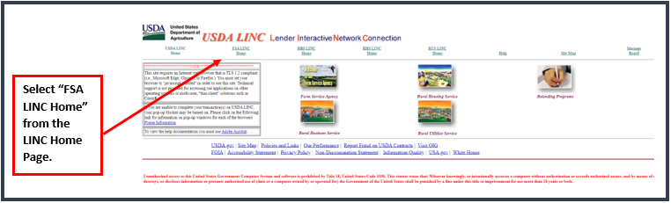
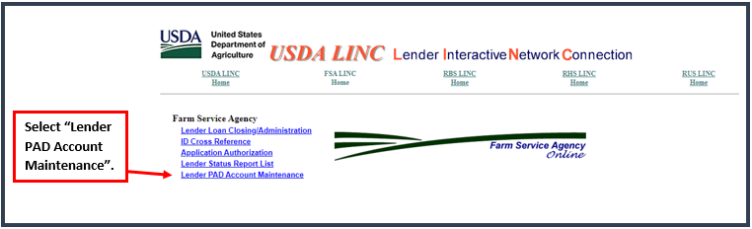
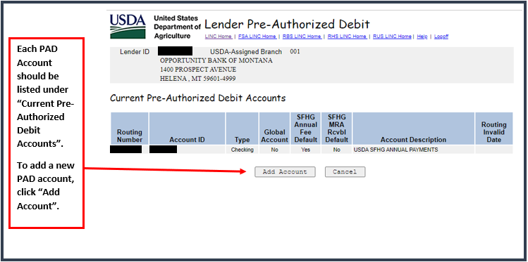
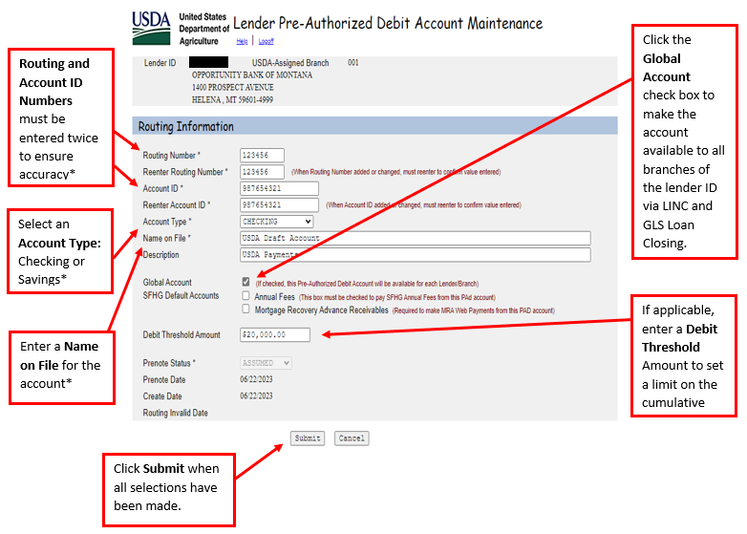
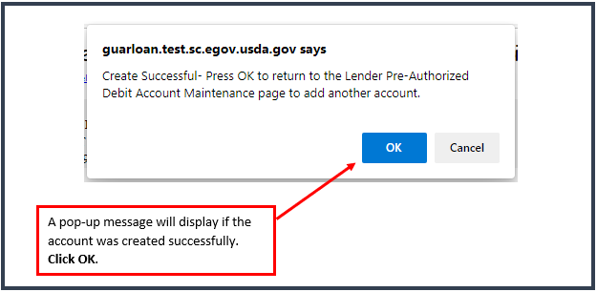
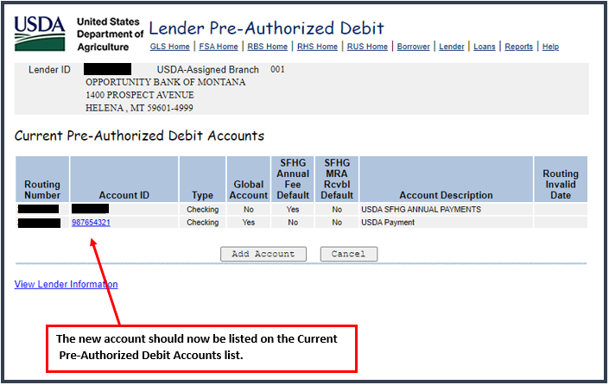

Lender Profile:
Users associated with more than one Lender Tax ID or Role must switch between Lender Profiles to access applicable loans. To switch to the necessary Lender Profile, Login to LINC at https://usdalinc.sc.egov.usda.gov/FSAhome.do and follow the steps below:

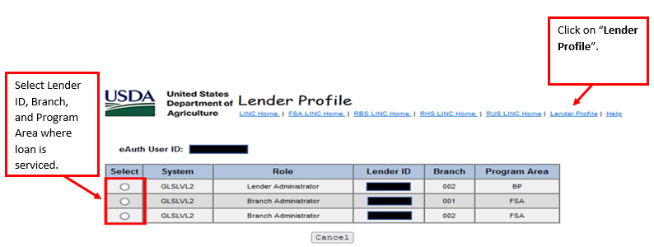
Helpful Tips-Technical
- On September 11, 2023, as part of Phase 1 of the transition to Login.gov, a new eAuth login page was introduced. The use of Login.gov is now optional for existing eAuth customer account holders, and all new customer accounts will be created with Login.gov. The full transition to Login.gov will require all public customers to use Login.gov to access USDA eAuth protected applications. For more information on Login.gov or customer login, please visit https://www.eauth.usda.gov/eauth/b/usda/faq.

***All existing eAuth account holders are highly encouraged to transition to Login.gov and link their accounts to eAuth.***
To use your Login.gov account with USDA, it must go through a one-time process to link with eAuth. Once it is linked, you can use it to access USDA protected resources. NOTE: Linking to an existing eAuth account will help to retain your relationship with applications you have accessed.

  - Click the Login.gov login option.
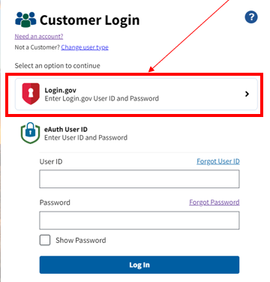
  - You will be taken to the Login.gov website, where you will log in with your existing Login.gov account or create a new Login.gov account.
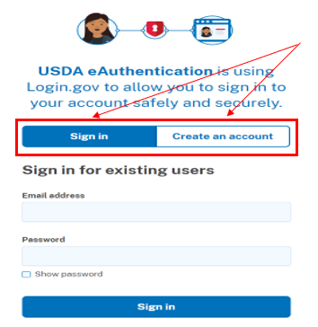
  - After logging in or creating the new account, you will be returned to eAuth to link your Login.gov account to eAuth.
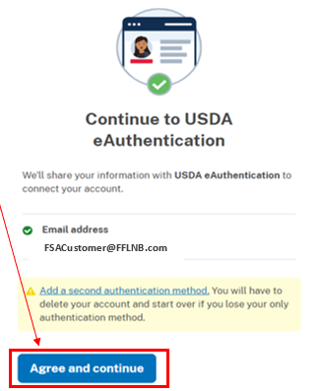
The linking process will vary depending on:
    - If the email address on the Login.gov account is using the same email address as an eAuth account, you will link automatically. You are informed the Login.gov account must be used for ALL future logins with USDA, and asked if you want to continue with the link to Login.gov by selecting Yes. You will be taken to the website or application.
    - If you don’t have an eAuth account in the system with the same email address as the Login.gov account, eAuth will ask if you want to use an existing eAuth account to link with Login.gov or continue without linking to an existing eAuth account?
    - If you have multiple eAuth accounts in the system matching the Login.gov email address, you will be notified multiple accounts were found. You will need to select the User ID from the list for the eAuth account you want to link with Login.gov. You will be prompted to log in with the selected User ID and password for the eAuth account to allow the link to continue.
    - If you experience problems logging in after linking your accounts, clear your browser cache and try again.
- For all user accounts created after June 24, 2020: Each email address can be associated to only one eAuth account. The email address used at account creation will be used to recover forgotten passwords. Users with current level 2 authority will not be affected by these changes. When a user changes their email address, the new email address becomes the new eAuth ID for the account. Once a user ID or email address is changed, AASM must be updated with new ID (See first bullet below).
- You may receive one of the below messages when trying to update a user role for a user who has changed their user ID or other eAuth-related instances. To correct this, either the lender administrator or USDA/FSA employee must remove the original user role and add the user’s new role using the new eAuth ID in AASM. (See instructions above for adding/removing security roles in AASM)
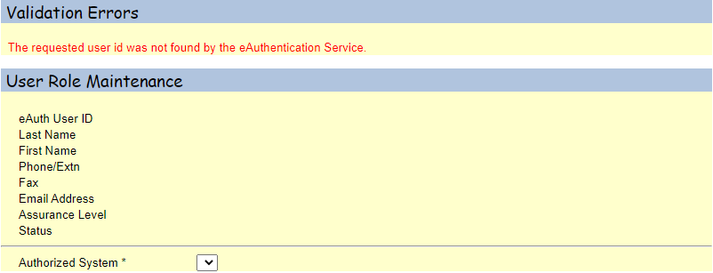

- You may receive one of the below messages when trying to add user roles to a new account after a user has updated their user ID. To add the new account in AASM, either the lender administrator or USDA/FSA employee must first inactivate the user’s existing account. The current lender administrator may not be able to maintain the user roles if the existing account is tied to another lender ID or a program that the administrator does not have access to. In this case the USDA/FSA employee will assist with the account inactivation in AASM. (See instructions in the screen print below for account Inactivation) 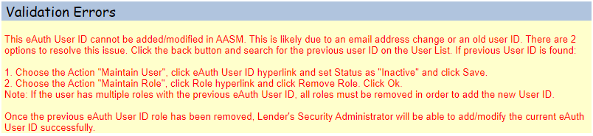 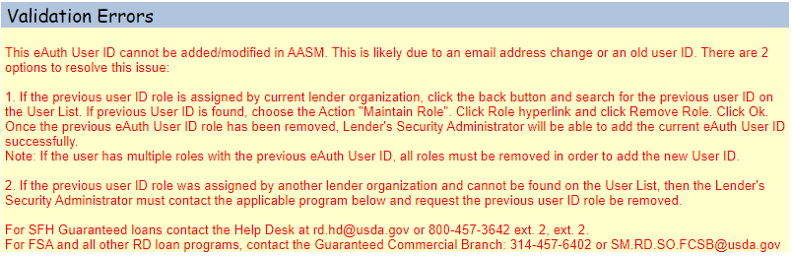
- Account Profile Information:
  - Name and date of birth may be updated if the account has not gone through the identity verification process. However, once your identity has been verified, you may not update your personal information.
- If your email address has changed or your account was created before June 24, 2020, then you may be able to update your name by creating a new account. Anytime a user creates a new account, the user must make sure their existing account is not tied to their current email address before creating a new account. (If a new account is created, and the email address matches the address of another account, then eAuth sign in process will not work.) To change an email address, the user must visit https://www.eauth.usda.gov/home/ and click on Manage Account. Users with a Login.gov account must add or delete an email address under Email preferences. Users without a linked Login.gov account can change their email address by clicking on the edit icon next to the account email address as shown below.
Login.gov Email Maintenance
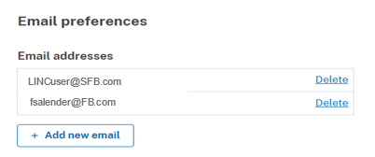0

eAuthentication Email Maintenance
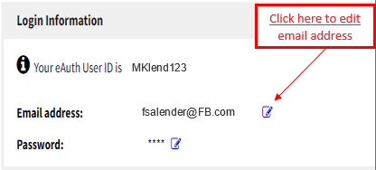
Note: New accounts must be reassociated to the lender ID in AASM.
  - Home address can be updated if the information was entered into the account profile.
  - Contact information (phone & fax numbers) can be updated if the information was entered into your account profile.
- To prevent inactivation of the eAuth account, the user should sign on quarterly at eAuthentication (usda.gov). For additional assistance with an eAuth account call the RD helpdesk at 1-800-457-3642; Option 1.
- The LINC site requires TLS 1.2. The following Browsers are supported: Chrome Version 84.0.4147.89; Microsoft Edge 44.17763.831.0; Internet Explorer 11; Firefox 78.0.2 or higher. You must set your browser to “javascript enabled” to use LINC.
- Please make the following adjustments to your browser (if needed). Please note that these settings can be removed/disabled due to a system update on the computer so may have to be adjusted again in the future.
  - If you are unable to complete your transaction(s) on USDALINC, your Popup Blocker may be turned on. Please click the following link for information on pop-up windows for of the browsers. Popup Information
  - If you are using Microsoft Edge or Mozilla Firefox and receive one of the below pop up messages DO NOT select the checkbox to disable popup messages. Click OK. Note: Selecting the checkbox will block any further transactions. If you select the checkbox in error, close and reopen your browser window.
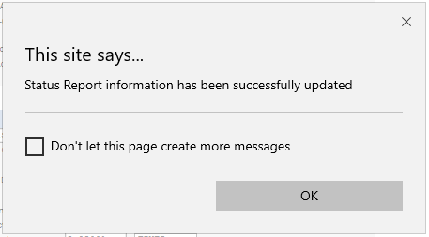
DO NOT CHECK
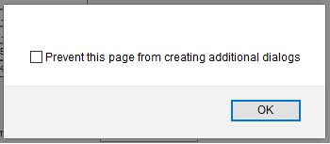
DO NOT CHECK
  - Compatibility View is no longer recommended for the USDALINC site. To remove usda.gov from Compatibility View settings, open your browser of choice and click on Tools>Compatibility View Settings. In the Compatibility View Settings window, select usda.gov in “Websites you’ve added to Compatibility View.” Click Remove and Close.
- Using the “Back” browser button can sometimes cause unpredictable results.
- USDA LINC is available for use Monday through Saturday from 6am to 7pm CST/CDT and Sunday from 8am to 4pm CST/CDT.
- To add LINC to your browser Favorites, be sure to add the LINC website and not the eAuth website.

