

Environmental Reviews for CREP Agreements

**Fact Sheet**

May 2022

USDA’s Farm Service Agency (FSA) is required to conduct environmental reviews for all actions, including the development and finalization of a Conservation Reserve Enhancement Program (CREP) agreement. The review considers the environmental effects of proposed projects and is required by the National Environmental Policy Act (NEPA), National Historic Preservation Act (NHPA), Endangered Species Act (ESA), and other laws.

# Environmental Reviews for CREP Agreements

Since CREP agreements impact larger geographic landscapes than most FSA actions, these agreements require a more detailed level of environmental review using an Environmental Assessment (EA) process. An EA is a concise document that evaluates the expected effects of the proposed agreement to determine if there is a potential for significant impacts to the environment. In addition to an EA being performed for the establishment of the CREP agreement, contracts entered into under the agreement will require site-specific environmental reviews. The site-specific review is a less detailed document demonstrating the action can be categorically excluded from requiring an EA.

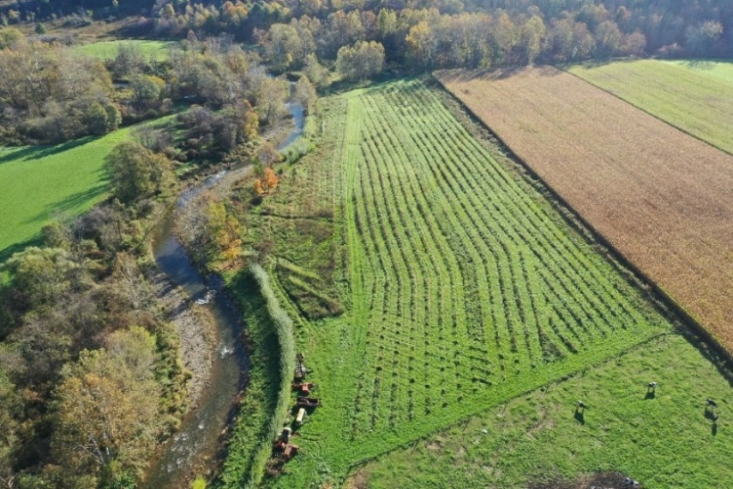

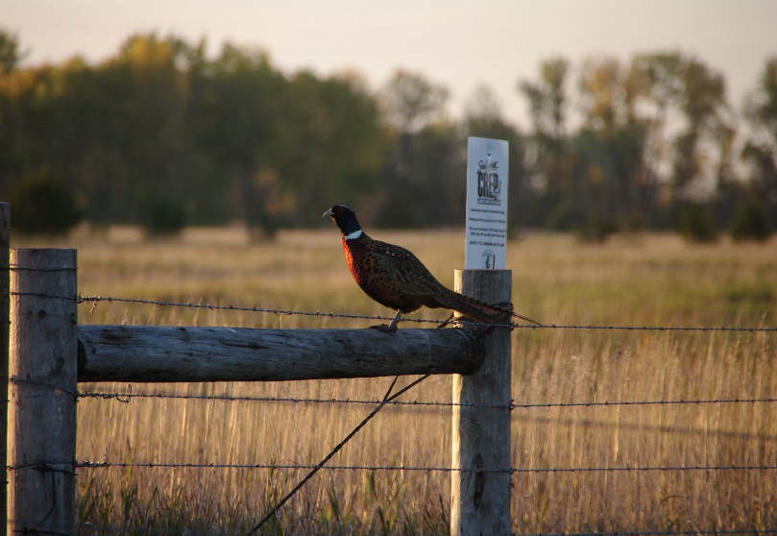

# Environmental Assessments:

## Protect Natural and Cultural Resources

The environmental assessment will address natural and cultural resources under Federal protection, including:

* Threatened and Endangered Species
* Cultural and Historic Resources
* Wetlands and Floodplains
* Air and Water Quality

## Require Public Involvement

NEPA requires that all EAs be made available to the public for their input and involvement. For CREP agreements, this will result in publishing a Notice of Availability (NOA) in local papers, or other reasonable alternatives, covering the geographic area of the proposed agreement. The public will then have 30 days to provide FSA comments on the proposed agreement prior to the finalization of the EA and CREP agreement.

## Take Additional Time to Complete

Many factors influence the time it will take to complete the EA -- the complexity of the project, effects on protected resources, and the public comments received. Understanding potential public controversy early in the process helps reduce potential delays.

USDA is an equal opportunity provider, employer, and lender.



**CREP AGREEMENT EA – MAY 2022**

# The EA Process

1. Develop a Draft EA.
2. Perform required consultations with regulatory agencies for potentially impacted protected resources (i.e., Tribes, State Historic Preservation Officer (SHPO), U.S. Fish and Wildlife Service).
3. Draft the NOA for publication in newspapers or other alternative media.
4. Publish the Notice in designated local papers or other alternative media.
5. Receive comments from the public for a minimum of 30 days.
6. Review and analyze the comments received to determine whether changes are needed.
7. Revise the Draft EA, if necessary.
8. If substantial revisions are made, publish a second NOA and receive comments for an additional 30 days.
9. Finalize EA and draft the Finding of No Significant Impact (FONSI).
10. FSA reviews and signs the FONSI and CREP Agreement.

# FSA EA Responsibilities

* FSA mustperform all required consultations (i.e., Tribal, SHPO, U.S. Fish and Wildlife Service, etc.) for the proposed CREP agreement. This is not a Federal responsibility that can be performed by a non-Federal entity.
* FSA is responsible for ensuring that all environmental reviews are completed and meets current regulations, prior to finalizing the CREP agreement.

# Partner EA Responsibilities

* Do not begin any project associated with a CREP agreement before the EA has been completed and a site-specific environmental review has been performed. Doing so may result in loss of program eligibility.
* Providing FSA with final details of the proposed CREP agreement up front will avoid unnecessary hurdles resulting from a change in scope. These critical details include agreement goals, desired practices, geographic location, acreage cap, etc.
* Except in rare and limited circumstances, partners will develop or contract the development of the Draft EA using funds provided by the partner.

# How to Get Started

Collaborate with your State FSA office on the details of the proposed CREP agreement prior to initiating the environmental assessment process.

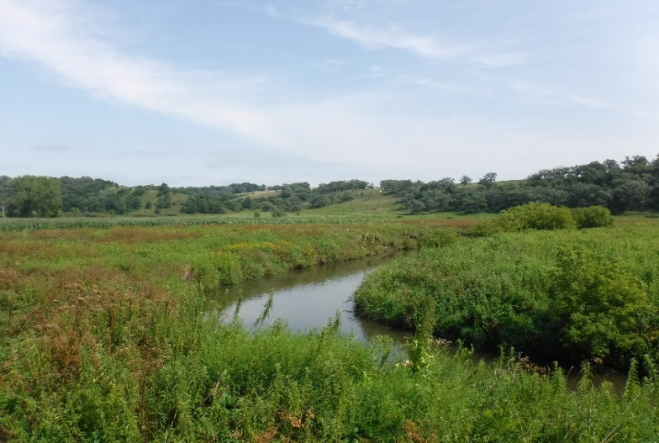

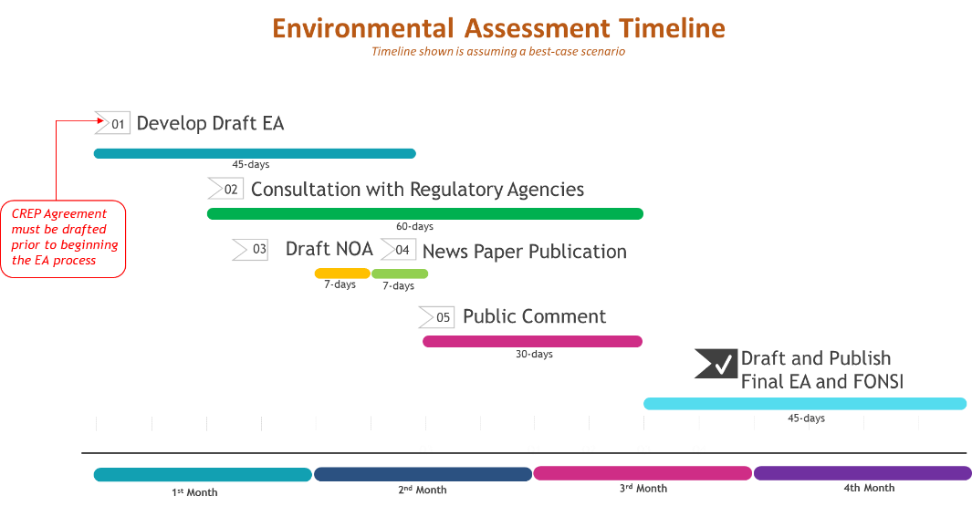

2