Is Your Farm or Ranch
HISTORIC?

It may be!

How long has it been in operation? What interesting events have happened there? Are any of its buildings old –fifty years or more?

Were they built in unusual ways? With unusual materials or designs? Or, perhaps, are they typical of buildings that used to be common in the area but are now getting scarce – big wood barns, tobacco drying sheds, chicken houses?

Has anyone lived there or worked there who’s been important in the history of the area?

These are the kinds of questions to ask when deciding whether your farm or ranch is historically important and possibly eligible for the National Register of Historic Places.

What is the National Register?

The National Register is a list of places that have been found to be significant in the history, prehistory, architecture, engineering, or culture of the nation, a state, an Indian tribe, a region, or a community. The Register is maintained by the National Park Service.

What if Your Farm or Ranch Is Historic?

If your farm or ranch is historically significant, the responsible thing to do is try to preserve what makes it that way. If you have to fix up the old barn, try to do it in a way that respects whatever makes the barn special. If you have to tear down the chicken houses, take some photographs of them first. Talk with experts in local history and architectural history about what you can do to preserve the historic character of your farm or ranch. What you do with your property is up to you, but you can often preserve its historic qualities at little or no cost and, by doing so, save something that future generations will greatly appreciate.

You can write or commission a nomination for your farm or ranch for inclusion in the National Register. In some states, you can also request inclusion in a State Register. If the nomination is accepted, you may be able to get grants or tax credits for preserving whatever it is that makes your farm or ranch historic – repairing the roof on the old barn, for example, or clearing the brush from the old irrigation channel. Whether such grants and credits are available depends on your state’s laws and programs, on annual federal appropriations, on what you want to do with your property, and a range of other factors.

Placing your farm or ranch on the Register -- or simply recognizing its eligibility without going to the trouble of nominating it – doesn’t change its ownership status in any way. You still own it, you can still do with it as you wish, subject—of course--to state and local environmental, planning and zoning laws.

If the Department of Agriculture or another Federal agency plans to do anything that might affect your farm or ranch – build a road through it, say, or assist you in putting in a new stock pond – the agency is required by law to determine whether your farm or ranch is historic and, if it is, to try to find ways to minimize (“mitigate”) damage to it. If you have already put together the information to show that it is (or is not) historic, this may help you argue against changes that you don’t like, as well as speed up and simplify agency review of projects that you do want, because the agency won’t have to go to the time-consuming trouble of figuring out your property’s significance.

How to Study Your Farm’s or Ranch’s History

- Talk with local history experts and architectural historians: you can probably find them through your local or county historical society, a college or university, or the State Historic Preservation Officer (SHPO).

- Document the history of your farm or ranch using your own property records; local, county and/or state histories; maps and aerial views; and family and historical society photographs. Talk to older people in your family or community about the farm’s or ranch’s history, and record what they say.

- Examine the buildings and structures – the house, barns, sheds, windmills, wells, silos, corrals, and compare them with those at other farms and ranches in the area. Read about the history of farm and ranch architecture in your area, and see how your buildings fit in.

For Further Information

For the names, addresses, phone numbers and email addresses of State Historic Preservation Officers, see http://www.ncshpo.org/

For State and local historical societies, see http://www.daddezio.com/society/hill/index.html

For an outstanding resource on American farm buildings, available through many local libraries and all bookstores. Try Barns and Outbuildings and How to Build Them. 1881 reprint [illustrated]. Lyons Press: 2000.

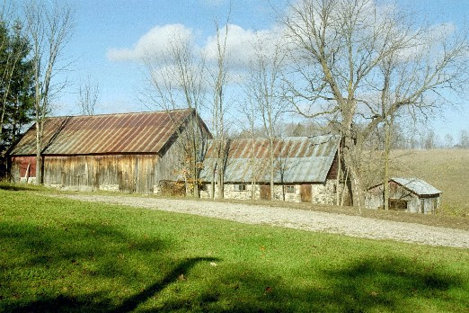
Photos courtesy of Michigan State University Extension – Otsego County, Michigan

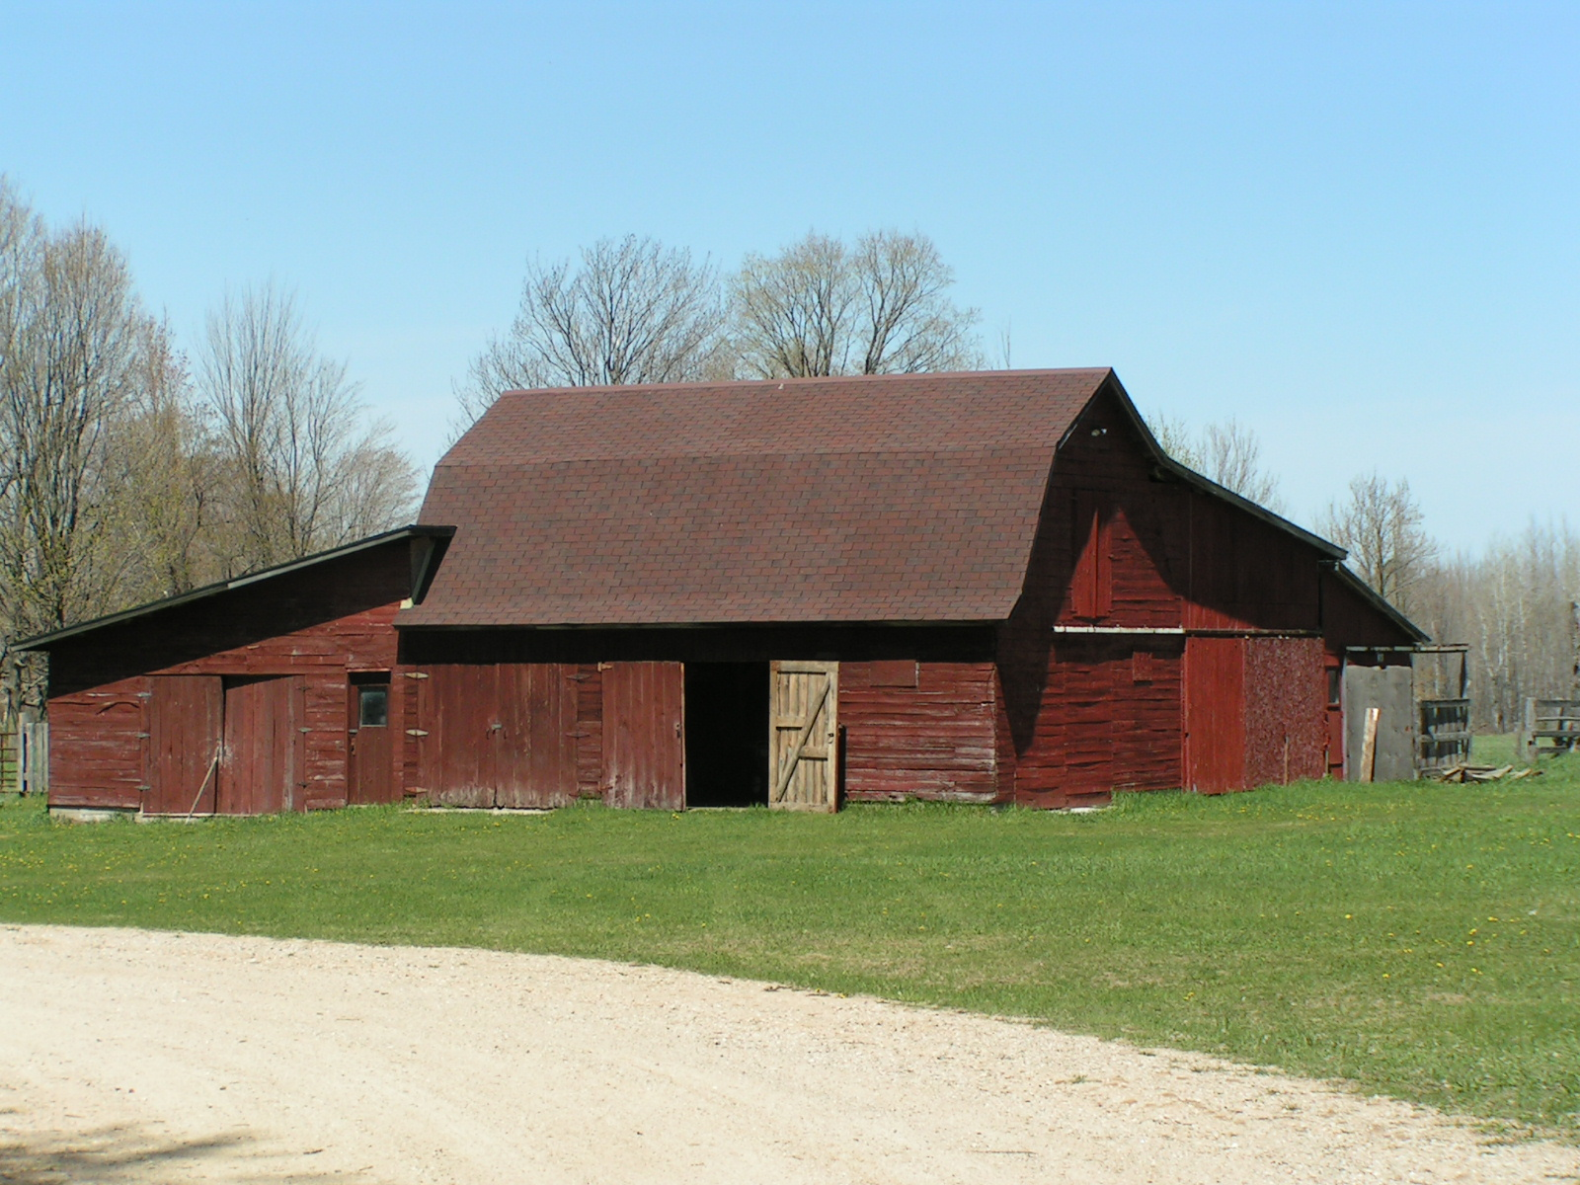
Photos courtesy of Michigan State University Extension – Otsego County, Michigan

